it is of age and not married and the branch blooms exactly on ChriCzech Christmas (Vánoce)
December 24 (Christmas Eve)
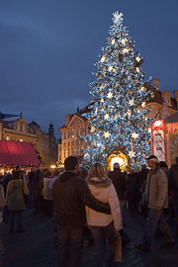
For many, December 24 (Štědrý den) is the most enjoyable day of Christmas holidays. Its Czech name literally means "Generous Day", probably for the wealth of food that has traditionally been served for Christmas dinner. Even poor families would make sure that their plates were full on this one day of the year.
December 24 is Adam and Eva's name day. The Christmas tree is decorated with traditional Czech Christmas ornaments in many households and preparations are made for the most festive dinner of the year. Christmas Eve is associated with many superstitions that usually relate to life, love, and destiny that awaits one in the year to come. According to one Czech Christmas custom, one is supposed to fast all day to see the "golden piglet" (zlaté prasátko) in the evening.
Christmas Dinner
Dinner is served after sunset (traditionally, it should not be served until after the first star has come out) and consists of carp and potato salad, sometimes preceded by mushroom, sauerkraut or fish soup. Did you know that carp can supposedly be prepared a hundred different ways? Christmas carp is specially

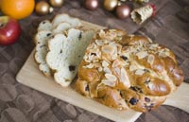  Vánočka, Czech Christmas bread | raised in manmade ponds and then sold from large tubs placed on the streets and town squares a few days before Christmas. You will not see this sight at any other time of the year. Some families keep their carp in the bathtub for several days as a temporary pet for their children... Dinner can be finished with dessert, such as apple strudel. A traditional Christmas bread called vánočka (similar to the Jewish challa) used to be a part of the Christmas dinner in the past but today it has largely lost its Christmas connotation and is available year-round.
Christmas Presents
After dinner, everyone around the table may sing Christmas carols before moving to the Christmas tree, which is all lit up and beautiful. By then, presents have been placed under the tree. Czech children believe that Christmas gifts are brought by Baby Jesus (Ježíšek) who comes into the room through the window to leave the presents. Unlike Santa Claus, Baby Jesus is a rather abstract figure with no particular physical image attached to him, and no one knows where he lives. Just like Santa though, he receives wish-list letters from Czech children a few weeks before Christmas.
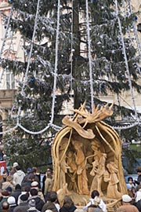
Midnight Mass
Some people end Christmas Eve by attending the midnight mass (půlnoční mše) at a local church.
December 25 - 26
Czech Republic Christmas stretches over December 25 and 26, which are also referred to as the First and Second Christmas Holidays, or the Christmas Feast (Boží hod vánoční) and St. Stephen's Day (Sv. Štěpán). On St. Stephen's Day, children, students, teachers, and the poor used to go around people's homes singing Christmas carols. Nowadays, families stay at home and relax or visit relatives and friends to share the special time.

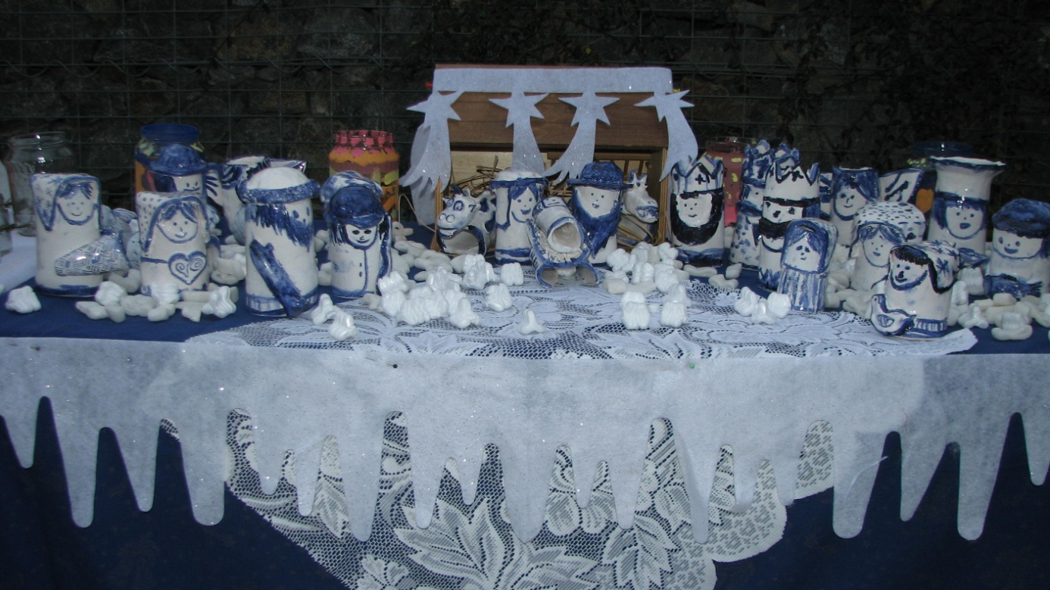

4 – St. Barbara’s Day—On this day a branch from a cherry tree is taken in
Foretelling the Future
The foretelling of the future and predicting the well-being of the family in the coming year is connected with many popular Christmas customs some of which are still practiced today
.
1.In our school
The Floating of Walnut Shells
Little boats are made out of empty walnut shells and each family member places a little burning candle into a shell. Everyone's shells are then floated on a bowl of water. If the shell makes it across the bowl, its owner will live a long and healthy life. A shell that sinks brings bad luck to its owner.

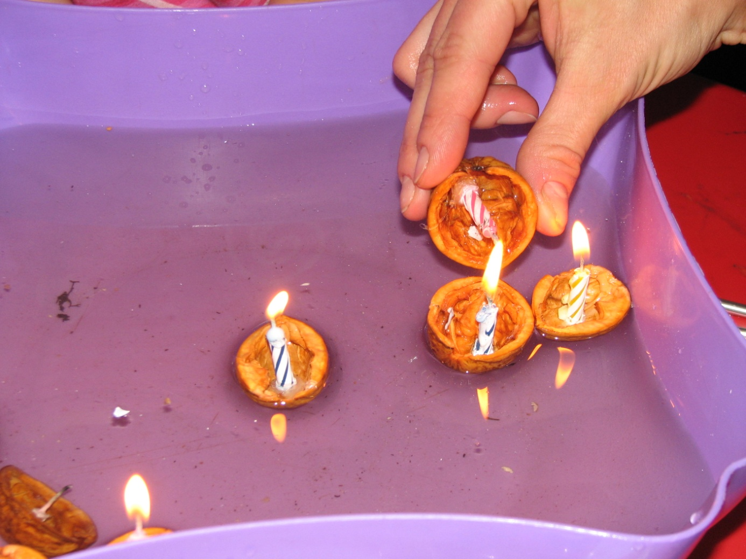
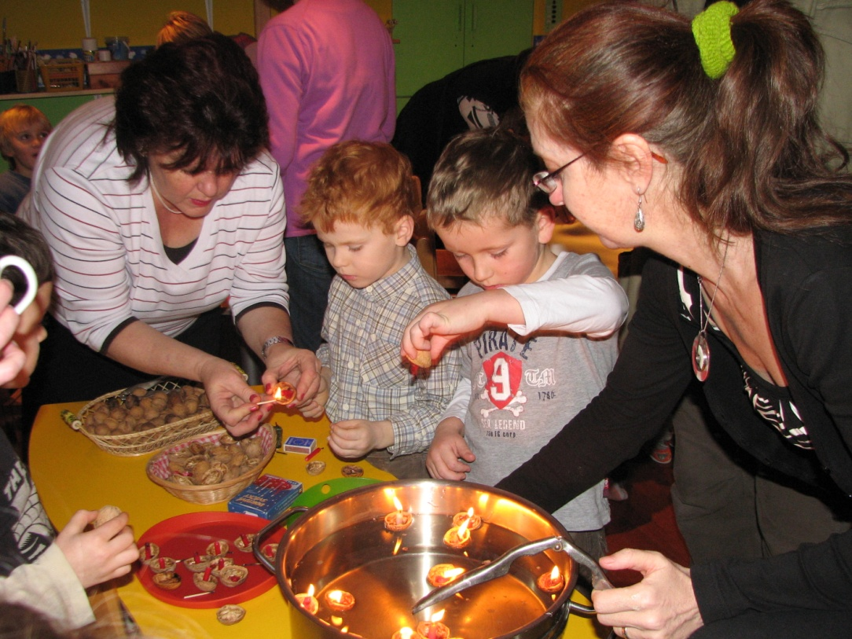
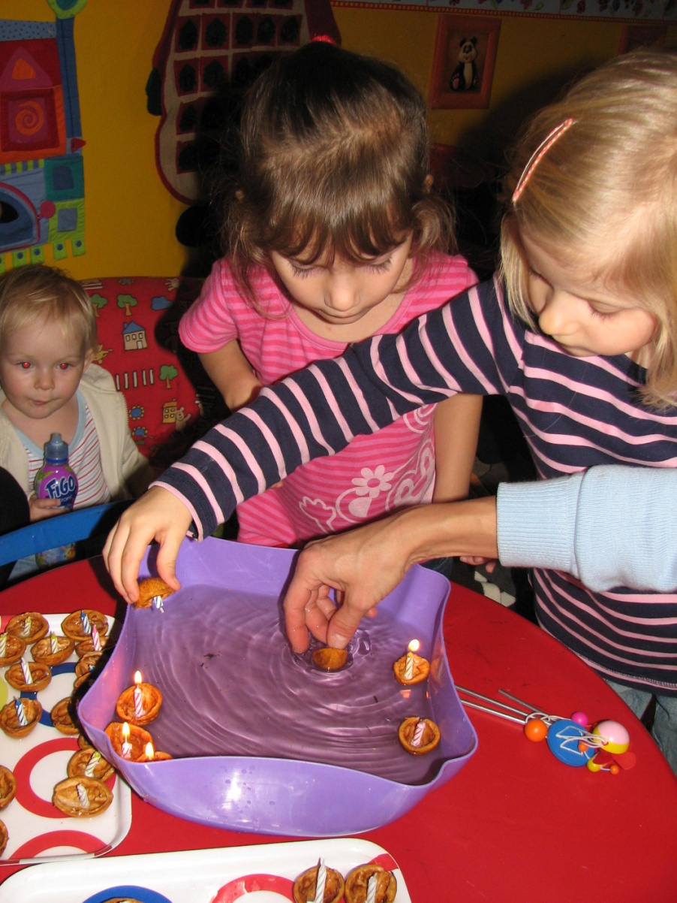
The Cutting of the Apple
After Christmas dinner, every person present at the table cuts an apple in half (crosswise, from the stem down). Both halves are shown to everyone around the table. If the core is shaped as a star, it means that everyone will get together next year in happiness and health. A four-pointed cross is a bad omen and means that someone at the table will fall ill or die within a year.
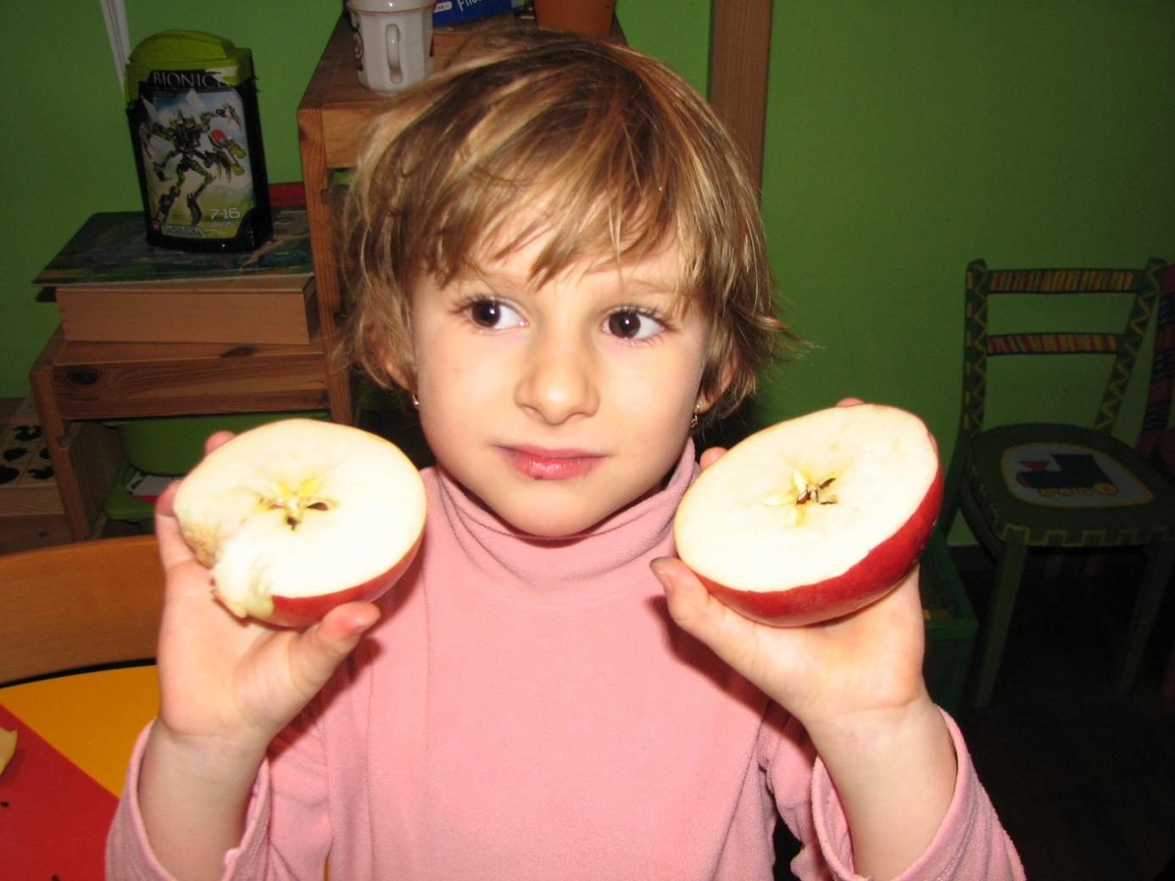
2.Next
Foretelling Marriage
There are lots of Christmas customs that help young girls in the family find out if they will get married in the year to come.
Cherry Tree Twigs (Barborky)
On December 4, St. Barbora's Day, an unmarried girl is supposed to cut a twig off of a cherry tree and put it in water. If the twig blooms by Christmas Eve, the girl will marry within a year.
The Throwing of the Shoe
An unmarried girl is supposed to throw a shoe over her shoulder and towards the door. If the shoe lands with the toe pointing towards the door, the girl will marry within a year.
Fish Scales
Fish scales should be placed under Christmas dinner plates or under the tablecloth to bring wealth to the house. Carrying a fish scale in a wallet all year will ensure that money will not run out.

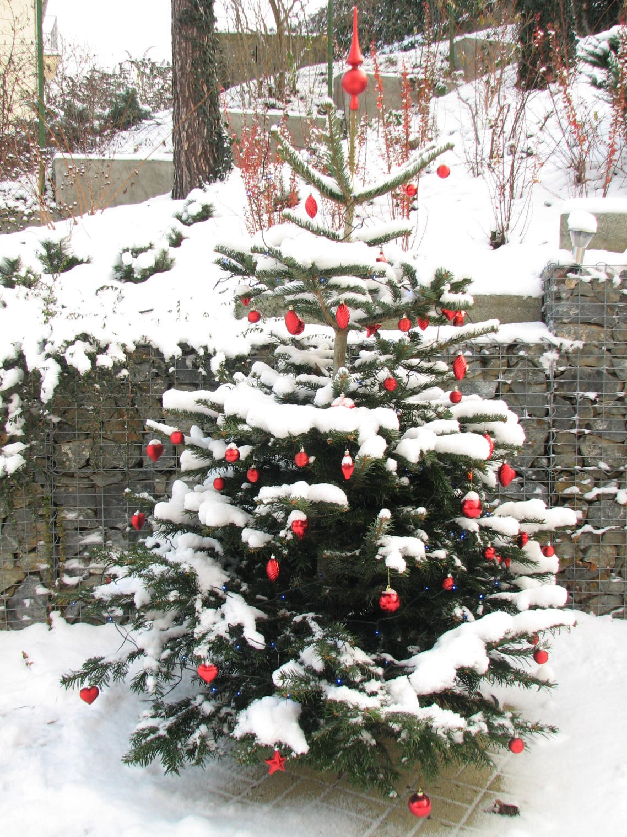Dec. 4 – St. Barbara’s Day—On this day a branch from a cherry tree is taken i

nside the kitchen and put into water. The branch then bursts into bloom during the Christmas season. This is considered good luck, and if the girl tending side the kitchen and put into water. The branch then bursts into bloom during the Christmas season. This is considered good luck, and if the girl tending it is of age and not married and the branch blooms exactly on Christmas Eve, she will find a good man and marry him within a year.
Dec. 6 – St. Nicholas Day—This is the feast day of Sv.Mikulas (Santa Claus) to both Slovak and Czech children. Sv.Mikulas walks around the village in his long red robe, accompanied by an angel holding a large book and a quill pen and the devil who is rattling large chains. Sv.Mikulas asks the village children if they have been good during the whole year. The angel writes down in the big book their answers. The child should sing a song or recite something for Sv.Mikulas. A bad child is told they could be put into the devil’s sack and taken to hell! On that evening if you have been good you could expect candy, nuts, fruit and small gifts in your shoes. If, on the other hand, you were not so good, expect potatoes, rocks, or lumps of coal. A tradition was that most children got at least one rock, as no child is perfect.
Dec. 24 – Christmas Eve—Preparations are made for celebrating Christmas: the tree is decorated, cookies are made, and bowls of apples and nuts are set around the house. A traditional evening meal of carp is served.
Dec. 25 – Christmas Day—The family attends church services and gathers around the table for a noon meal.
Dec. 26 – St. Stephen’s Day—Children go caroling for treats.
Dec. 31 – New Year’s Day—Celebrated with eggnog.
Jan 6 – Three King’s Day or Epiphany—Young boys dress as the kings and go caroling for treats.
c. 4 – St. Barbara’s Day—On this day a branch from a cherry tree is taken inside the kitchen and put into water. The branch then bursts into bloom during the Christmas season. This is considered good luck, and if the girl tending it is of age and not married and the branch blooms exactly on Christmas Eve, she will find a good man and marry him within a year.
Dec. 6 – St. Nicholas Day—This is the feast day of Sv.Mikulas (Santa Claus) to both Slovak and Czech children. Sv.Mikulas walks around the village in his long red robe, accompanied by an angel holding a large book and a quill pen and the devil who is rattling large chains. Sv.Mikulas asks the village children if they have been good during the whole year. The angel writes down in the big book their answers. The child should sing a song or recite something for Sv.Mikulas. A bad child is told they could be put into the devil’s sack and taken to hell! On that evening if you have been good you could expect candy, nuts, fruit and small gifts in your shoes. If, on the other hand, you were not so good, expect potatoes, rocks, or lumps of coal. A tradition was that most children got at least one rock, as no child is perfect.
Dec. 24 – Christmas Eve—Preparations are made for celebrating Christmas: the tree is decorated, cookies are made, and bowls of apples and nuts are set around the house. A traditional evening meal of carp is served.
Dec. 25 – Christmas Day—The family attends church services and gathers around the table for a noon meal.
Dec. 26 – St. Stephen’s Day—Children go caroling for treats.
Dec. 31 – New Year’s Day—Celebrated with eggnog.
Jan 6 – Three King’s Day or Epiphany—Young boys dress as the kings and go caroling for treats.
good man and marry him within a year.
Dec. 6 – St. Nicholas Day—This is the feast day of Sv.Mikulas (Santa Claus) to both Slovak and Czech children. Sv.Mikulas walks around the village in his long red robe, accompanied by an angel holding a large book and a quill pen and the devil who is rattling large chains. Sv.Mikulas asks the village children if they have been good during the whole year. The angel writes down in the big book their answers. The child should sing a song or recite something for Sv.Mikulas. A bad child is told they could be put into the devil’s sack and taken to hell! On that evening if you have been good you could expect candy, nuts, fruit and small gifts in your shoes. If, on the other hand, you were not so good, expect potatoes, rocks, or lumps of coal. A tradition was that most children got at least one rock, as no child is perfect.
Dec. 24 – Christmas Eve—Preparations are made for celebrating Christmas: the tree is decorated, cookies are made, and bowls of apples and nuts are set around the house. A traditional evening meal of carp is served.
Dec. 25 – Christmas Day—The family attends church services and gathers around the table for a noon meal.
Dec. 26 – St. Stephen’s Day—Children go caroling for treats.
Dec. 31 – New Year’s Day—Celebrated with eggnog.
Jan 6 – Three King’s Day or Epiphany—Young boys dress as the kings and go caroling for treats.

